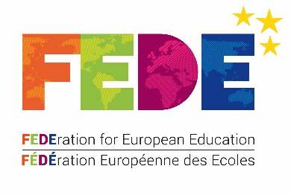

FEDE Human Rights Prize

Practical guidance for entrants

In addition to the Rules, which provide specific information on the competition, the following recommendations will help ensure your competition entry meets the FEDE’s requirements.
- - - - - - - - - -
Entries must be submitted by student(s) enrolled in a FEDE degree programme at a FEDE member institution. They must focus on a subject connected with human rights.

- The main aim of the prize is to promote awareness, protection and application of human rights.
- The entry must constitute an action that advances human rights. Student(s) should choose one or more topics. They may use the examples provided for inspiration.

Examples of topics and issues that might be addressed

- The rule of law and human rights
  - Why is the rule of law essential for the protection of human rights?
- Migration and human rights
  - Why is it particularly important to protect the human rights of migrants?
- Sustainable development and human rights
  - How can activities in favour of sustainable development help protect human rights?
- Gender and human rights
  - How does gender equality help to protect human rights?
- Culture, language and human rights
  - How do intercultural relations help to protect human rights and, in particular, the human rights of minorities?
- Youth and human rights
  - How can young people play an active role in protecting human rights?
- Education and human rights
  - How does ensuring everyone has access to quality education help to protect human rights?
- Civil society and human rights
  - Why is it that many civil-society organisations and NGOs are committed to protecting the human rights of people they do not even know?

Guidelines for the project summary to be submitted with your entry

The summary must include the following:

- A cover page stating:

  - The name of:
    - your educational institution + your country;
    - the entrant(s) (first name and surname) and their email address;
    - the supervising teacher (if you have one).
  - The FEDE degree in which each of the entrants is enrolled
  - The title of your entry
  - The topic
  - The FEDE logo
  - A brief overview of the entry (5 to 10 lines)

- A detailed explanation of the project (1 to 2 pages)

Your entry, which must be submitted along with the summary described above, can take any form: a piece of writing (poem, manual, brochure), audiovisual material (video, videogame), music (song, concert), visual art (sculpture, painting, poster), an exhibition, a performance (choreography, play), a comic book, a PowerPoint presentation, the organisation of an academic seminar, a lecture, a debate, etc.

Use of both French and English: In judging the entries, the FEDE will look favourably on entries that are accompanied by a summary in both English AND French.

You can find full information on the FEDE’s Human Rights Prize here:
https://www.fede.education/en/human-rights-prize/
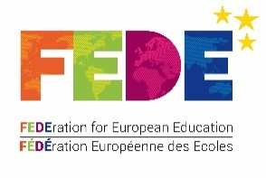

Please note that, in conformity with a vote of the Council of Europe's Conference of INGOs, the Federation for European Education (FEDE) prefers the term ‘droits humains’ in French (‘human rights’ in English); this term is considered more inclusive than ‘droits de l’Homme’ [‘rights of mankind’].
Human rights are inalienable, indivisible and universal, and they imply both rights and obligations. Legislation: universality, non-discrimination.

